



Z Cooler Automation Rev 0.00

We started with the automation of the col. Nothing else has been automated yet. The Col has been redrawn from scratch and is now automated. Each of the col’s have a weldment page followed by a detail page of the component. We have renumbered the col’s so you do not have to renumber them for a 1Z or no sub col jobs. The pages will go blank. If not used on the job. So, if the sheet is missing the dwg views you can delete the page for the current job.

When you start a job. Start as usual.

1. In the top asm change the 3D sketch to the correct dims.
2. Then (control Q) and the col heights will update as usual.
3. Then pick the correct config to use, at this time. In the future we will automate this as well.
4. Next open the Col asm and the Col part. Make sure they are both on the Left Front Config for the design table to work properly.
5. Start with the col part file first. Open the design table and make your changes.
6. Choose from the 4 drop downs in the table (shown below) and save the file.
7. Then go to the col asm and open and close the table. It will now update.
8. Then save the file. That is all you need to do to update the col.

In the col part design table you will have 4 drop down questions to answer to properly update the col you will need for your current job.

. 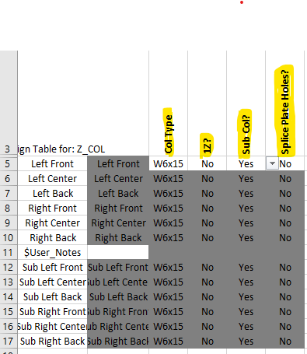

Col Type = W6 or W8 col size

1Z? = is it a 1Z Yes or No

Sub Col = Does it have Sub Col’s Yes or No

Splice Place Holes = Does it use Splice Plates Yes or No

In the Col Asm table. This table will automatically update based on the col size. You will have the option to override the drop down options for the col base and join plates and flags for job specific parts. Otherwise these columns will be blank.

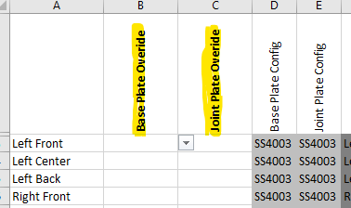

These are the current changes to the Master.

More automation will be coming in the future.

Rev 0.01

Fixed broken references on derived sketches and patterns on panels and col’s.

Had to re-dimension panel mtg holes on Col Dwg.

Rev 0.02 – Bugscreen Automation

Added automation to the BUG-PNL ASSY. The bugscreen panels have been remodeled and new dwgs. The old ones don’t work any more. It is very similar to the COL automation.

When you have a bugscreen.

Start with the Bug-Pnl Assy. Open the design table and make your changes.

Choose from the 2 drop downs in the table (shown below) and save the file.

Then go to the BUG-PNL ASSY Dwg and the BUG ASM Dwg. They should automatically update.

Then go to the BPA dwgs. You will have to manually finish updating them. (see below)

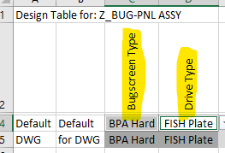

Choose the bugscreen type: BPA Hard or BPL Soft.

Choose the Drive type: Fish Plate or H Drive.

When you change from Fish Plate to H Drive or back, Item 21600 will show up int the bill. on the bug panel dwgs. You will have to hide it.

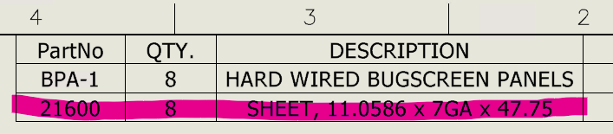

Now there is only one dwg file for each bug panel (BPA-1 thru 8). The same file will be used for BPA and BPL. If you update the dwg properly it will show up in flatter files correctly. So you must open each file and do the following.

1. Open each BPA file. The bill should update and be correct.
2. Then click on the dwg view.
3. Change it to the configuration to match the bill. (BPL or BPA)
4. Then (control Q) and the dwg and title block will update.
5. Check to make sure everything matches. P/N on view, bill and Title block should all match.
6. Last of all delete the red note on dwg view.
7. Save file. Repeat for all the bug panels.
8. On BPA dwgs less than 36” wide or long, suppress the center hole. On that edge.

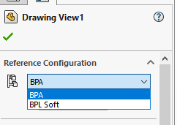

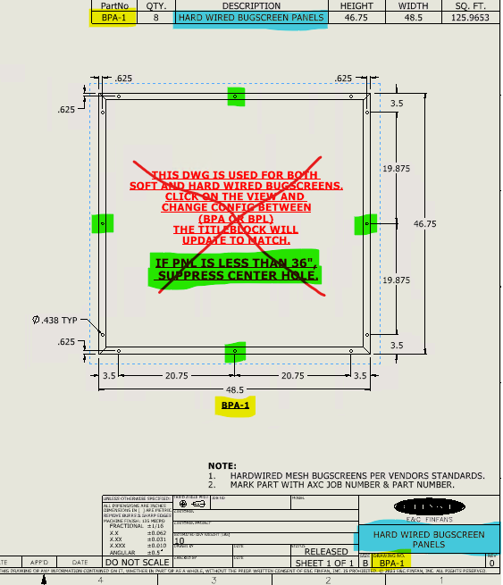

Rev 0.03 – DRIVE MOUNT (DRM) Automation

We have added automation to the DRM ASM. The drm models along with the dwgs have been updated. It now has only the Default configuration. This means that you will no longer have to make sure the dwg views are looking at the correct config. But it will cause other problems to the dwgs if they are not used on the current job. This will be addressed later, in more detail.

When you start working on the drm.

1. Start with the drm part model.
2. Open the design table and make your changes.
3. Choose from the 2 drop downs in the table (shown below).
4. Next enter the center distance from the parts list document (PLT).
5. After you have made your selections, Close the design table and save the file.
6. Now open the design table in the DRM Assembly model.
7. You will have 2 drop downs in this table. Chose the Bearing Size and the Motor Size.
8. Then close the table. It will now update the assembly.
9. Then save the file. That is all you need to do to update the DRM.

DRM Part Design Table.

Drive Type.

|  |
| --- |
| Standard 15 |
| Mini 12 |

The Standard is a 15” drive Channel. Used on most Z Coolers. 108” and above.

The Mini is a 12” drive Channel used on small Coolers. 96” and below.

Drive Mtg Table.

|  |
| --- |
| Fish Plate |
| Fish Plate w Bugscreen |
| H Drive |
| H Drive w Bugscreen |

Choose from these 4 options.

On small coolers with small bearings, you can change the tube size. For bearing bolt clearance.

DRM Assembly Design Table.

Chose the Bearing Size and the Motor Size.

You on a rear occasion can rotate the bearing from 45 to 90 degrees.

Rev 0.04 – REMOVED (NO SUB COL) CONFIGS in Assembly Model

Removed all the (No Sub Col) configs in the Top Assembly model of the cooler. They have not been necessary since the Col Assembly was automated.

Rev 0.04 – ADDED NEW WALKWAY

The walkway was completely remodeled with new dwgs. This was necessary due to the old one would mess up the bills just by changing configs. The old model was made sometime before 2007. It was time for a new and improved one.

In the assembly turn on the walkways needed. In the Column turn on the walkway mtg holes so the walkway does not float.

The walkway is now tied to the Assembly and Column Model. As the cooler gets wider or narrower, the walkway will as well. You no longer need to change the dim for the W6/W8 option. It will automatically update as well.

The mounting holes and bracing will automatically update to match the col size after the col model is updated. Don’t forget to turn on the mtg holes in the Column assembly.

There is now a true top-down bill for the complete walkway asm. The rest of the dwg package will look almost the same. However, there is now a page with details of the items with holes.

No change on this page.

On weldment pg-2, The Magenta dims have been moved to the next page. The detail page.

The magenta dims are still there but are hidden if for some reason you need them.

Removing the dims makes this page less cluttered. Plus, if you have an extension to connect walkways for example, you won’t see the holes any way. That is the reason the for the detail page and hiding of the dims.

On the detail page by default only the yellow items are visible. The extension items, highlighted in blue are hidden. They should remain hidden unless you are using the extension features. If you need more details just add a page.

The extension items will be explained on next page.

Extension items are turned on below. They can be turned on in any config in any variation.

In the tree unsupress the feature(s) needed. This can be as small as for connecting walkways or as large as to be used for a landing for a sidestep ladder, ect.

To move the handrails out is much easier than before. Double click on the end handrail or just edit the 3D Sketch for Handrails. Change the dim for the side you are changing. Match the extension dim. Also change the bar grating in the same manor, to match handrails.

Rev 0.05 – FAN DECK (FDK) Automation

Have added automation to the FDK ASM. The FDK now has design table with a drop down for the fan size. This makes it easy change between all the fan sizes we currently use. It quickly changes the fan cutout Dia., the Dia. of the slots, and the qty. of the slots.

FDK Design Table.

Choose from a 42” fan to a 192” fan.

There will be more automation of the FDK that will be addressed later.

UPDATED Z Cooler ASM Automation Rev 0.06

Updated the automation of the Top ASM, to remove the Splice Plate, DMS (H Drive), Bugscreen, Splice Plates & 1Z Configs. These options are now automated in the Top ASM design table.

I have added more automation to the Z Cooler ASM.

I have removed all configurations but three.

**Default**

**Mid Col-DMS-Splice Plate**

**FE**

First, I have changed the COL Color to light brown. Nothing else has changed. I changed the color to better see where it is in the model when you click on it in tree.

The configs I have removed are now built into the design table in the ASM model.

Just choose from these 4 options. When you close the Design Table it will update the model.

Just like the other design tables in the components. I would update the subcomponents first.

Especially the drm. Otherwise, the FSH /DMS components will not mate properly.

Below are the new drop-down options.

First choose how many fans your cooler will have. (1-3)

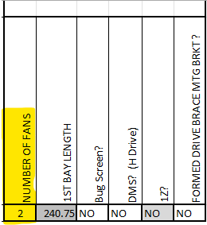

Choose if you have a DMS? (H Drive).

Choose if you have a Bug Screen?

Note: If you have a bug screen and a 3Z, do all your other choices first. Get the model the way you need it. Then reopen the design table. Then pick the bug screen option. It will cause less problems. When you have a bug screen you will have to manually have to edit the “LocalLPattern-3Z”. Suppress or remove the drive braces. When it is a 3Z is the only time you will have to manually edit it. I did not have time to put this into the automation.

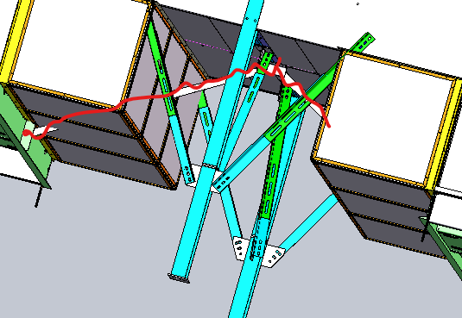

Choose if you have Splice Plates?

On occasions where the drive mount brace interferes with the fan ring/guard.

When this happens, we will use this option. (Seldomly used).

**You will have to edit the 3Z pattern if you have a 3Z.**

Choose if you need a formed drive brace mtg bracket?

